IT 453. Hands-on exercises.
Class work/Homework 3.
Objectives:
- Analyze the types of database failures
- Practice In Performing Recovery of Database operations.
Resources:
- Use as a reference “Oracle Database 11 g Administrator. Certified Associate”,
“Recovering the Database ” - ch.16 .
- Videos
Hands-On:
- Use RMAN to restore database to a prior point in time
- Change directory to d drive and path name
- Type rman target /
- Ready to receive rman commands now.
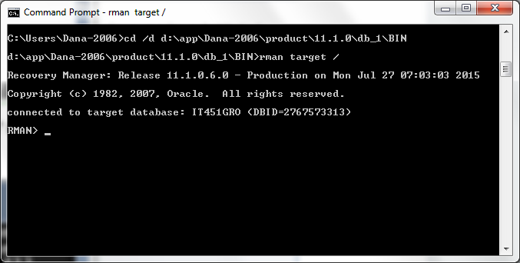

- SHOW ALL; ( shows current configurations and location of the current rman backup.

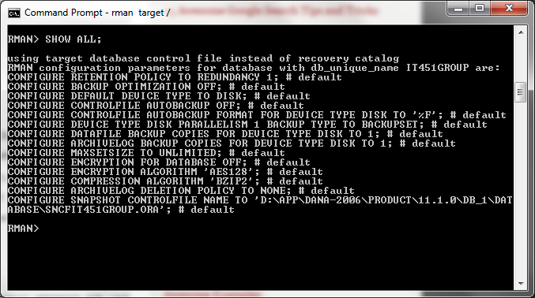

Which gives the result:
“configure snapshot controlfile name to
‘D:\APP|DANA-2006\11.10|DB_1|DATABASE|SNCFIT451GROUP.ORA’

e) RESTORE DATABASE PREVIEW;
Allows a list of all recovery dates
Gives SCN number:4540147 for example.

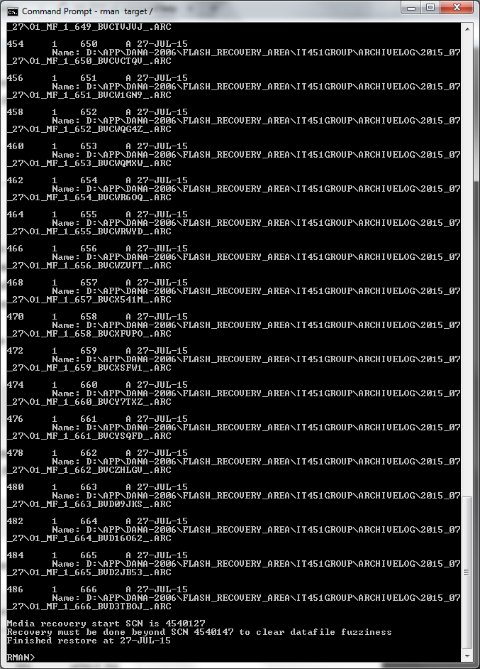

RESTORE DATABASE PREVIEW SUMMARY;
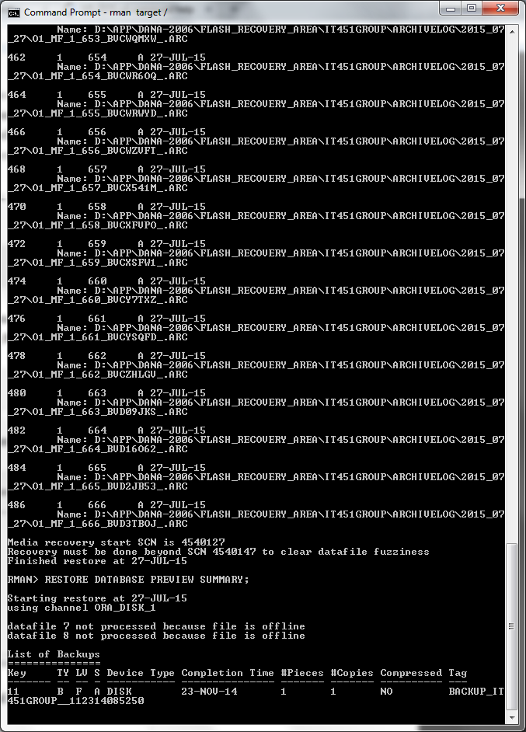

- STARTUP NOMOUNT;

Second attempt:
Shutdown immediate;
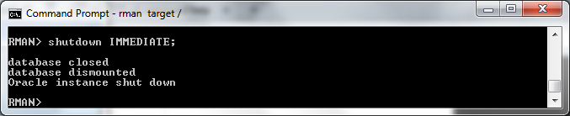
STARTUP NOMOUNT;
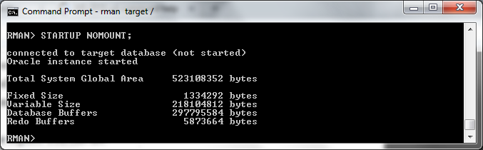
RESTORE CONTROLFILE FROM” FILE NAME HERE”;
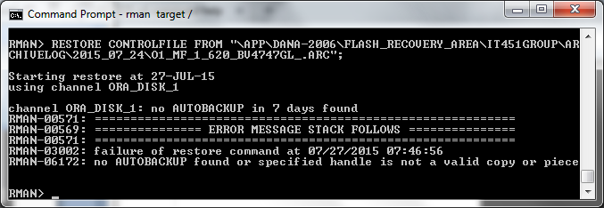

- ERROR MSG:I found I needed to do a backup. So I :
shutdown immediate;
startup mount;
database backup;

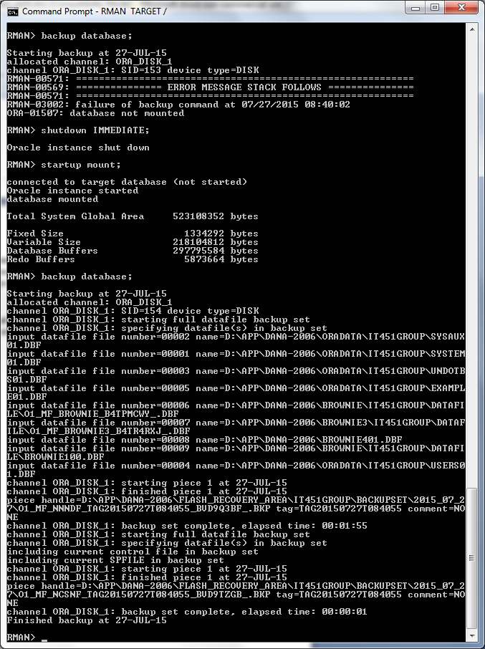
then I continued attempt #3.
Because I did not back or have automatic backups set up, oracle gives me this error. I am unable to continue. But feel I have shown many useful commands.
Then using rman I had issues with allowing the db to “open”. I had to shutdown immediate;
Startup mount;
Alter database open;
Then proceed to question #2.
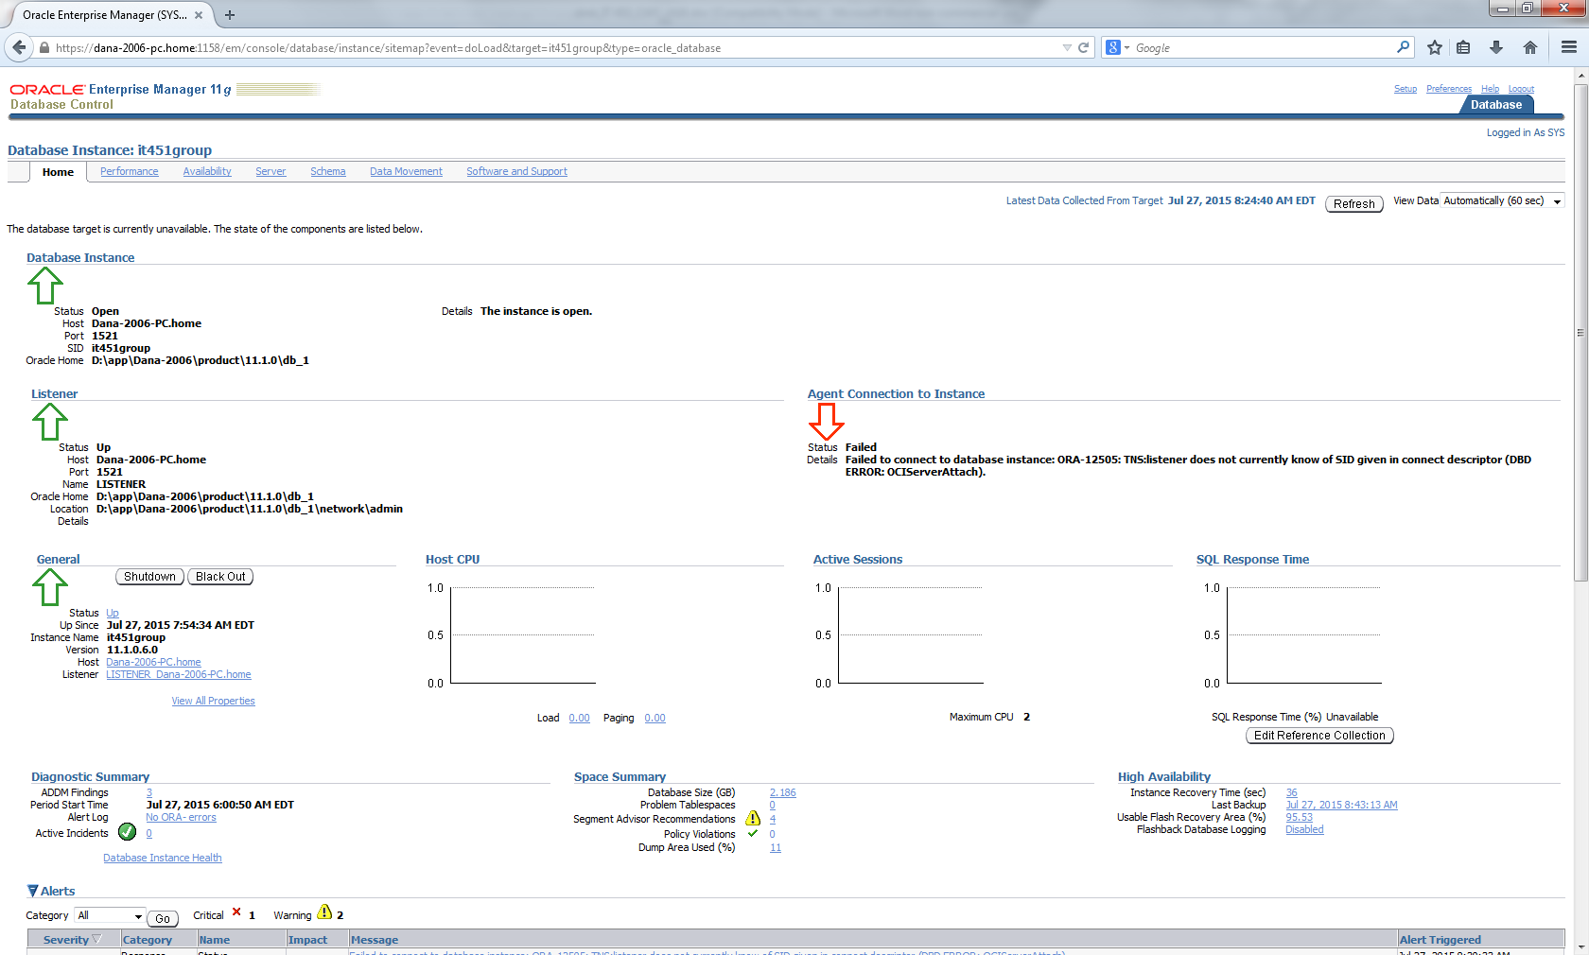

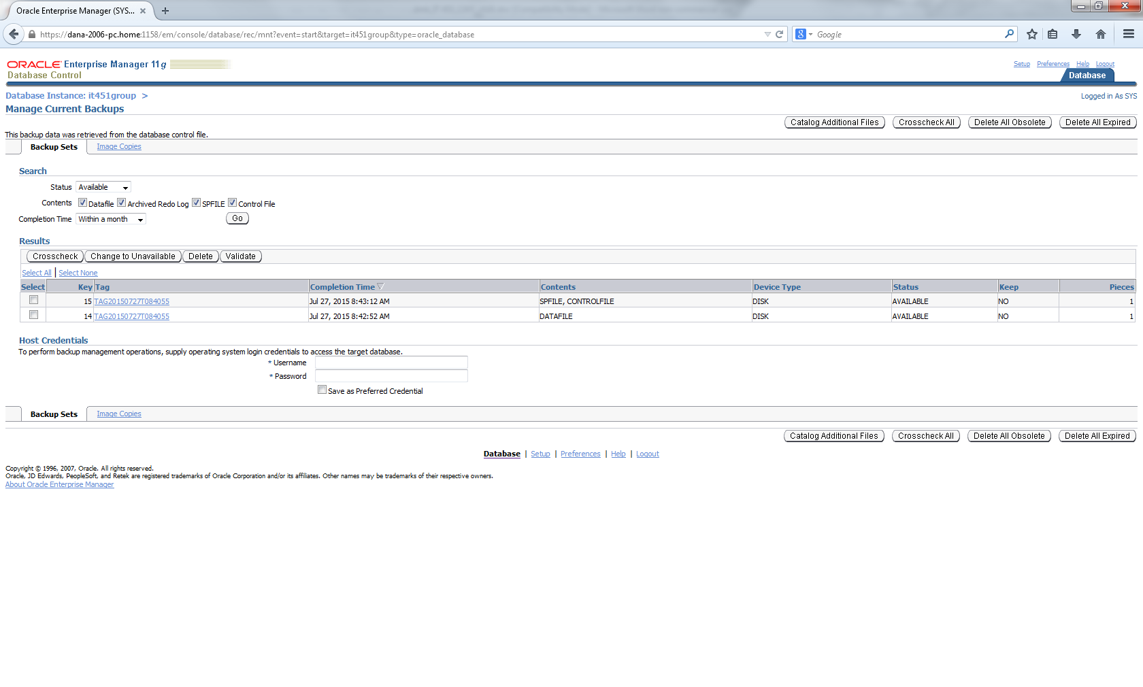

Also firefox was attempting updates that were interfering with the EM usage.

- Use database control to restore/recover database
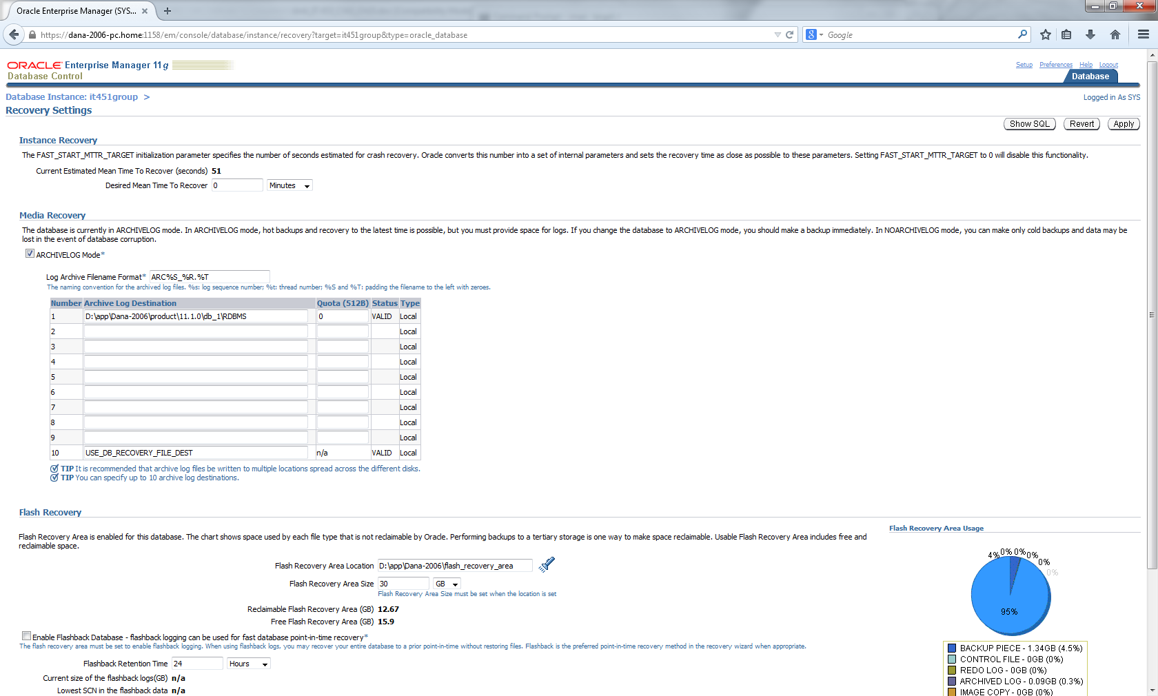

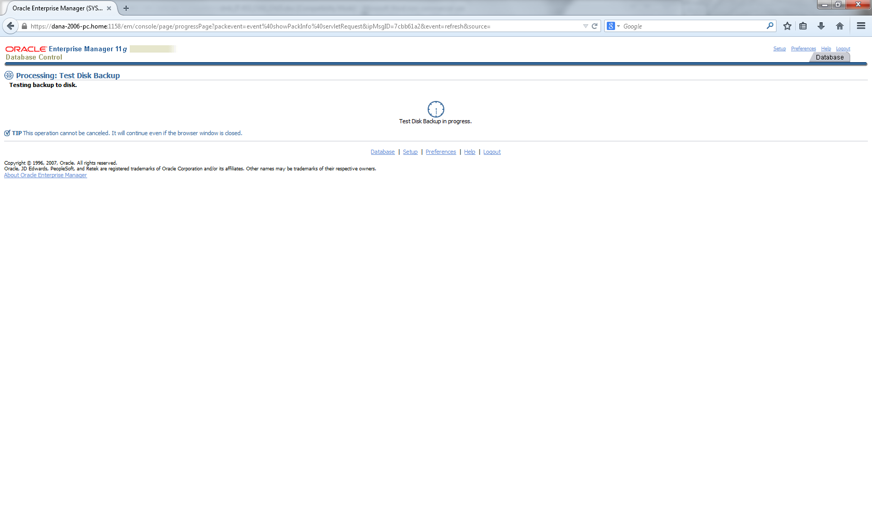
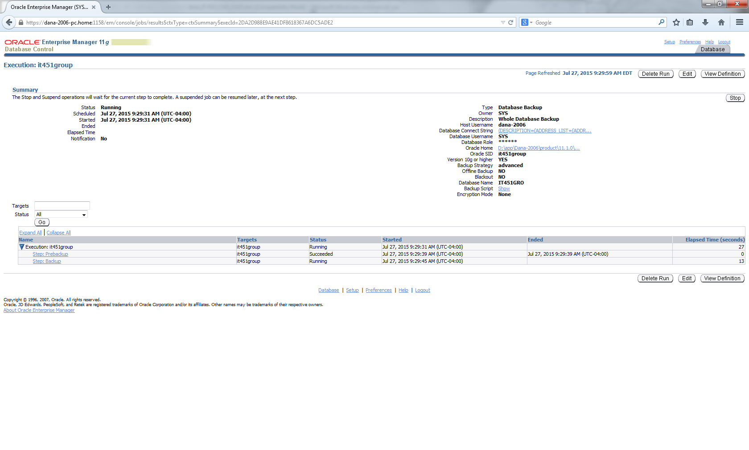
- Use Recovery Advisor to restore/recover database
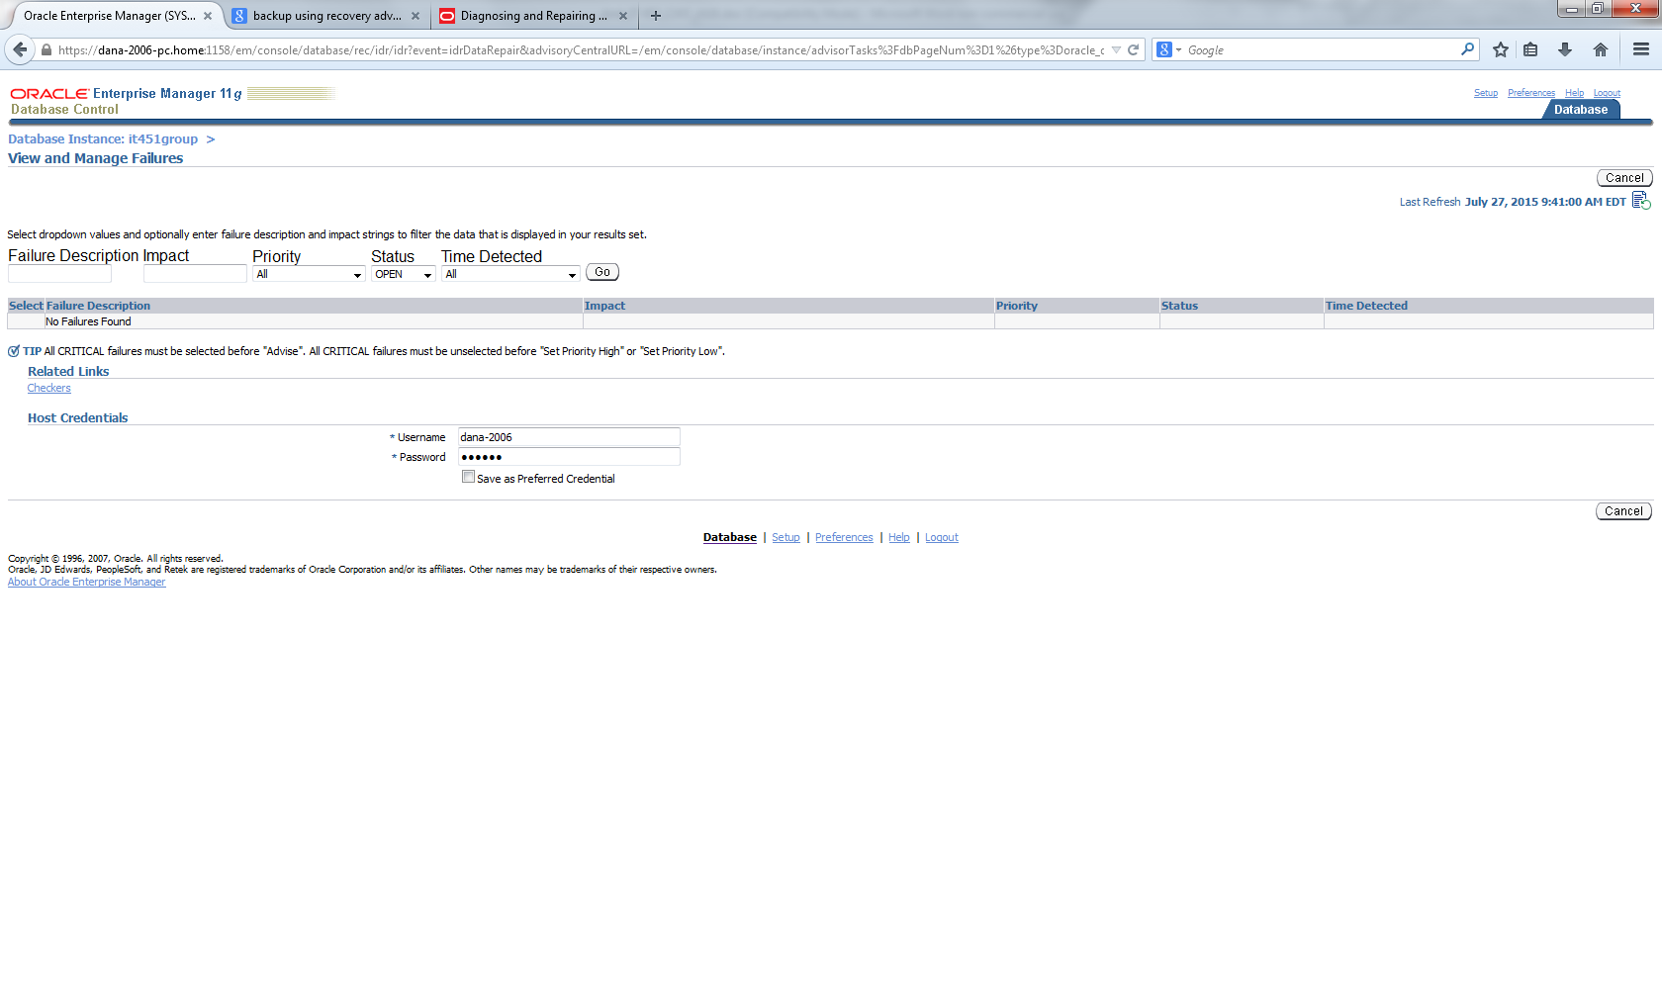
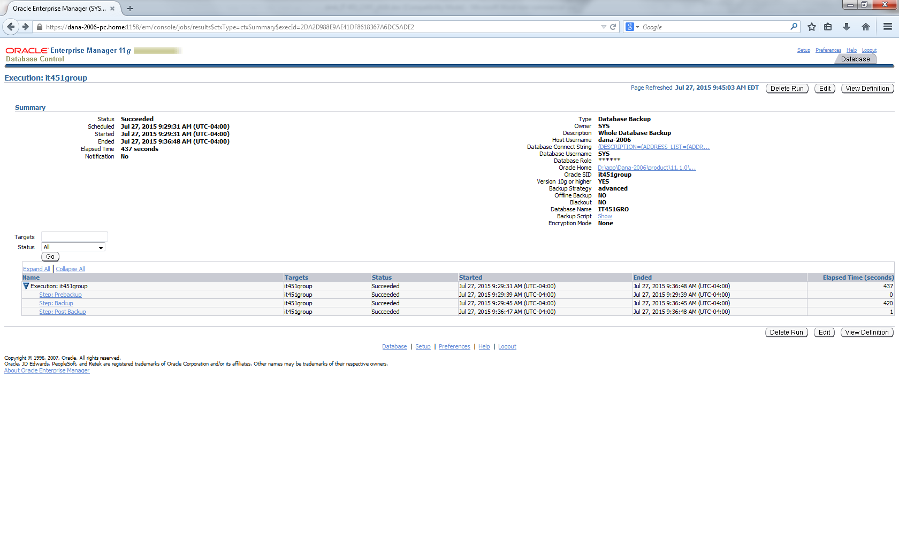

- Practice different recovery scenarios

The advisor did not have selections when there were no failures. Many failures were handled automatically. Due to the database being down and not in use, there were no automatic backups and this seemed to interfere with the ability to recover data from older time periods without a newer backup created as a safety feature.

